**BIKE CRASH DETECTION**

## A PROJECT REPORT

***Submitted by,***

**SHIVANI M 20201CSE0862**

**DEEPIKA H S 20201CSE0882**

**NAVYASHREE 20201CSE0884**

**YASHWANTH M 20201CSE0893**

### *Under the guidance of,*

**Dr. SHARMASTH VALI Y**

***in partial fulfillment for the award of the degree of***

**BACHELOR OF TECHNOLOGY**

**IN**

**COMPUTER SCIENCE AND ENGINEERING**



**PRESIDENCY UNIVERSITY**

**BENGALURU**

**JANUARY 2024**

**PRESIDENCY UNIVERSITY**

**SCHOOL OF COMPUTER SCIENCE & ENGINEERING**

**CERTIFICATE**

#### This is to certify that the Project report **“BIKE CRASH DETECTION”** being submitted by SHIVANI M, DEEPIKA H S, NAVYASHREE, YASHWANTH M bearing roll number(s) 20201CSE0862, 20201CSE0882, 20201CSE0884, 20201CSE0893 in partial fulfilment of requirement for the award of degree of Bachelor of Technology in Computer Science and Engineering is a bonafide work carried out under my supervision.

|  |  |
| --- | --- |
| **Dr. SHARMASTH VALI Y**  Assistant Professor  School of CSE&IS  Presidency University | **Dr. PALLAVI**  Associate Professor & HOD  School of CSE&IS  Presidency University |

|  |  |  |
| --- | --- | --- |
| **Dr. C. KALAIARASAN**  Associate Dean  School of CSE&IS  Presidency University | **Dr. SHAKKEERA L**  Associate Dean  School of CSE&IS  Presidency University | **Dr. SAMEERUDDIN KHAN** Dean  School of CSE&IS  Presidency University |

**PRESIDENCY UNIVERSITY**

**SCHOOL OF COMPUTER SCIENCE & ENGINEERING**

**DECLARATION**

We hereby declare that the work, which is being presented in the project report entitled **“BIKE CRASH DETECTION”** in partial fulfilment for the award of Degree of **Bachelor of Technology** in **Computer Science and Engineering**, is a record of our own investigations carried under the guidance of **Dr. SHARMASTH VALI Y,** **School of Computer Science Engineering & Information Science, Presidency University, Bengaluru.**

We have not submitted the matter presented in this report anywhere for the award of any other Degree.

|  |
| --- |
| **NAME** **ROLL NUMBER** **SIGNATURE**  SHIVANI M 20201CSE0862  DEEPIKA H S 20201CSE0882  NAVYASHREE 20201CSE0884  YASHWANTH M 20201CSE0893 |

**ABSTRACT**

Tis research focuses on the development and evaluation of a bike crash detection system leveraging sensor data and machine learning algorithms. The study aims to assess the feasibility and accuracy of such a system in identifying and responding to bike accidents promptly. The methodology involves integrating accelerometers and gyroscopes on the bike to capture motion data, which is then processed through a machine learning model trained on crash-related patterns. The system's performance is evaluated across various biking scenarios and conditions to ensure robustness and reliability. Results indicate a high level of accuracy in detecting bike crashes, with the potential to significantly reduce emergency response times. The research explores the practical implementation of this technology, emphasizing its potential to enhance cyclist safety. Challenges such as false positives and environmental factors are addressed through fine-tuning of the algorithm. The study concludes by highlighting the promising outlook for widespread adoption of bike crash detection systems and recommends further research to optimize and validate the proposed approach in real-world settings, ultimately contributing to improved bike safety measures. This research focuses on developing and evaluating a bike crash detection system using sensor data and machine learning algorithms. The methodology involves integrating accelerometers and gyroscopes on the bike to capture motion data, processed through a machine learning model trained on crash-related patterns. Results indicate a high accuracy in detecting bike crashes, potentially reducing emergency response times significantly. The study explores the practical implementation of this technology to enhance cyclist safety, including the integration of GPS technology for accurate location information during accidents. The research also delves into user-friendly interfaces and communication mechanisms for effective notification of both cyclists and emergency.

**ACKNOWLEDGEMENT**

First of all, we indebted to the **GOD ALMIGHTY** for giving me an opportunity to excel in our efforts to complete this project on time.

We express our sincere thanks to our respected dean **Dr. Md. Sameeruddin Khan**, Dean, School of Computer Science Engineering & Information Science, Presidency University for getting us permission to undergo the project.

We record our heartfelt gratitude to our beloved Associate Deans **Dr. Kalaiarasan C and Dr. Shakkeera L,** School of Computer Science Engineering & Information Science, Presidency University and **“Dr. PALLAVI R”**, Head of the Department, School of Computer Science Engineering & Information Science, Presidency University for rendering timely help for the successful completion of this project.

We are greatly indebted to our guide **Dr. Sharmasth Vali Y, Assistant Professor**, School of Computer Science Engineering & Information Science, Presidency University for his inspirational guidance, and valuable suggestions and for providing us a chance to express our technical capabilities in every respect for the completion of the project work.

We would like to convey our gratitude and heartfelt thanks to the University Project-II Coordinators **Dr. Sanjeev P Kaulgud, Dr. Mrutyunjaya MS** and also the department Project Coordinators **“Mr. Zia Ur Rahman, Mr. Penial Jhon Whistely”.**

We thank our family and friends for the strong support and inspiration they have provided us in bringing out this project.

**SHIVANI M**

**DEEPIKA H S**

**NAVYASHREE**

**YASHWANTH M**

**LIST OF TABLES**

|  |  |  |  |
| --- | --- | --- | --- |
| **Sl. No.** | **Table Name** | **Table Caption** | **Page No.** |
| 1 | Table 2.1.1 | Literature Survey Table | 6 |

**LIST OF FIGURES**

|  |  |  |  |
| --- | --- | --- | --- |
| **Sl. No.** | **Figure Name** | **Caption** | **Page No.** |
| 1  2  3  4  5  6  7  8  9  10  11  12  13  14  15  16  17  18  19  20 | Figure 6.1.1  Figure 6.1.2  Figure 6.1.3  Figure 6.1.4  Figure 6.1.5  Figure 6.2.1  Figure 6.2.2  Figure 6.2.3  Figure 7.1.1  Figure 7.1.2  Figure 7.1.3  Figure 7.1.4  Figure 7.1.4.1  Figure 7.1.4.2  Figure 7.1.4.3  Figure 7.1.5  Figure 7.1.6  Figure 7.3.1  Figure 9.1.1  Figure 9.1.2 | GPS Neo 6M  Arduino Nano  ADLX 335 Accelerometer  GSM SIM800I Module  LM2596 Step Converter  Blynk GSM Manager  GSM, Aceutils, Adafruits BusIO  Library Manager  Use Case Diagram  State Diagram  Activity Diagram  Data Flow Diagram  Level 0  Level 1  Level 2  ER Diagram  System Architecture  Gantt Chart  Alert Message  Location tracking | 18  20  20  21  21  22  22  22  23  24  25  26  26  26  27  28  29  32  39  40 |

**TABLE OF CONTENTS**

|  |  |  |
| --- | --- | --- |
| **CHAPTER NO.** | **TITLE** | **PAGE NO.** |
|  | **ABSTRACT** | iv |
|  | **ACKNOWLEDGEMENT**  **LIST OF TABLES**  **LIST OF FIGURES** | v  vi  vii |
| **1** | **INTRODUCTION**  1.1 Scope and objectives | 1  3 |
| **2** | **LITERATURE SURVEY**  2.1.1 Literature Survey Summary | 6  7 |
| **3** | **RESEARCH GAPS OF EXISTING METHODS**  3.1 Disadvantages of Existing system | 8  9 |
| **4** | **PROPOSED METHODOLOGY**  4.1 Advantages of Proposed system  4.2 3.1 Disadvantages of Proposed system  4.3 Working Principle | 11  12  13    14 |
| **5**  **6** | **OBJECTIVES**  **HARDWARE & SOFTWARE REQUIREMENTS**  **6.1 Hardware Requirements**  **6.2 Software Implementation** | 16  18  18    22 |
| **7** | **SYSTEM DESIGN AND IMPLEMENTATION**  7.1 DESIGN  7.1.1 Use Case Diagram  7.1.2 State Diagram  7.1.3 Activity Diagram  7.1.4 Data Flow Diagram  7.1.4.1 Level 0  7.1.4.2 Level 1  7.1.4.3 1 Level 2  7.1.5 ER Diagram  7.1.6 System Architecture  7.2 IMPLEMENTATION  7.2.1 MODULES  7.2.1.1 Module Description | 23  23  23  24  25  26  26  26  27  28  29  30  30  30 |
|  | 7.3 Timeline For Execution Of Project. | 32 |
| **8** | **TESTING**  8.1 Feasibility Study  8.1.1 Economic Feasibility  8.1.2 Operational Feasibility  8.1.3 Legal and regulatory Feasibility  8.1.4 Environmental Feasibility  8.1.5 Social Feasibility  8.1.6Scheduling and opportunity Feasibility  8.2 System Testing  8.2.1 Various levels of testing  8.2.1.1 Hardware Integration Testing  8.2.1.2 Connectivity Testing  8.2.1.3 Security Testing  8.2.1.4 Power Consumption Testing  8.2.1.5 Sensor Accuracy and Reliability Testing  8.2.1.6 Interoperability Testing  8.2.1.7 Scalability Testing  8.2.1.8 Environmental Testing | 33  33  33  33  33  33  33  34  34  34  34  34  34  35  35  36  36  36  37 |
| **9** | **RESULTS AND OUTCOMES**  9.1 Screenshots of the results | 38  39 |
| **10** | **CONCLUSION & FUTURE SCOPE** | 41 |
|  | **REFERENCES** | 42 |
|  | **APPENDIX-A**  **APPENDIX-B** | 43  48 |

**CHAPTER-1**

**INTRODUCTION**

The surge in popularity of cycling as a mode of transportation and recreation has accentuated the critical need for inventive safety measures to safeguard cyclists. At the forefront of cyclist safety concerns lies the imperative task of promptly detecting and responding to bike accidents. This research embarks on the development and comprehensive evaluation of an advanced bike crash detection system, harnessing the capabilities of sensor data and cutting-edge machine learning algorithms. Central to this study is the exploration of the feasibility and precision of a specialized system crafted to swiftly identify and respond to bike accidents. The methodology involves the integration of state-of-the-art accelerometers and gyroscopes onto the bicycle, strategically positioned to capture an exhaustive set of motion data. This dataset undergoes intricate processing through a machine learning model, purposefully trained on patterns indicative of bike crashes. By leveraging these innovative technologies, the research aims not just to detect crashes but also to substantially reduce emergency response times, potentially mitigating the severity of injuries.

In a departure from traditional crash detection approaches, this study introduces the integration of GPS technology into the system. This addition serves a dual purpose, providing accurate location information during accidents and expediting emergency response and intervention. The real-time spatial data offered by GPS enhances the system's effectiveness, ensuring a more accurate and prompt deployment of emergency services. The practical implementation of this technology extends further into the development of user-friendly interfaces and communication mechanisms. The objective is to guarantee that notifications reach not only emergency responders promptly but also the cyclists involved in the accident. This holistic approach underscores a commitment to a system that addresses both the technical aspects of crash detection and the human-centric requirements for effective intervention. Privacy concerns associated with such systems are acknowledged and meticulously addressed within the research. Measures, including the anonymization of personal data and the implementation of secure communication channels, are explored to instill confidence in users regarding the safeguarding of their sensitive information. This conscientious approach aims to strike a balance between the potential benefits of the crash detection system and the imperative need to protect user privacy.

Furthermore, the study recognizes that the success of any safety technology hinges on user

acceptance and preferences. To this end, user feedback is incorporated through surveys and usability testing, ensuring that the system is not only technologically sound but also aligns with the needs and expectations of cyclists. This iterative process of refinement is integral to optimizing the system's usability across diverse biking scenarios and conditions. Looking forward, the research envisions potential collaborations with bike manufacturers and municipal authorities. Integrating the crash detection system into the design of bicycles and urban infrastructure could realize a comprehensive and proactive approach to cyclist safety. The ultimate objective of this research is to contribute original insights and technological advancements that will aid in preventing and mitigating the impact of bike accidents, fostering a safer environment for cyclists on the roads.

In the contemporary landscape of urban mobility, cycling has emerged as an increasingly popular and sustainable mode of transportation and recreation. Yet, the inherent vulnerability of cyclists on roadways necessitates the continual development of innovative safety solutions to mitigate the risks associated with bike accidents. This research endeavors to contribute to the evolving paradigm of cyclist safety through the creation and meticulous evaluation of an advanced bike crash detection system, which amalgamates sensor data and cutting-edge machine learning algorithms. At the crux of this investigation is the nuanced exploration of the viability and precision of a specialized system designed for the rapid identification and response to bike accidents. The methodological framework is anchored in the integration of state-of-the-art accelerometers and gyroscopes meticulously embedded onto the bicycle, strategically positioned to capture a comprehensive spectrum of motion data. This trove of data undergoes intricate processing via a purposefully trained machine learning model, discerning patterns indicative of bike crashes. The overarching goal is not merely the identification of crashes but, crucially, the substantial reduction of emergency response times to potentially ameliorate the severity of injuries sustained. In a divergence from conventional crash detection methodologies, this study introduces an innovative integration of GPS technology into the system architecture. This augmentation serves a dual role, furnishing precise location information during accidents and expediting emergency response and intervention. The real-time spatial data afforded by GPS substantially augments the system's

efficacy, ensuring a more accurate and prompt deployment of emergency services.

The demand for creative solutions to lessen the severity and effects of accidents has grown in recent years due to the growing concern for road safety, particularly with regard to two-wheeled mobility. Being common forms of transportation, motorcycles and bicycles are more

likely to be involved in collisions that cause significant injuries or even fatalities. It is becoming more and more obvious how important quick action is in these kinds of circumstances.

Conventional safety protocols mostly concentrate on responding to crashes after they have occurred, greatly depending on bystanders or emergency services to provide prompt aid. On the other hand, the built-in delay of these devices may be harmful to the safety of riders in collisions. Identifying this gap, the proposed project proposes to introduce a Bike Crash Detection System with an integrated alarm system in order to overcome the shortcomings in

the existing safety frameworks.

The urgent necessity to create an automated, proactive system that can quickly recognise bike incidents and notify emergency contacts is what motivated this research. Through the utilisation of new developments in motion sensors, GPS, and communication modules, the system aims to transform the way that two-wheeler incidents are responded to.

According to estimations from the World Health Organisation (WHO), motorbike and bicycle accidents considerably contribute to the worrisome statistic that road traffic injuries are one of the major causes of mortality worldwide. Seeing this, our Bike Crash Detection System comes into play as a prompt intervention to improve riders' safety net by making sure that help is not only sent out quickly but also has vital location data.

Furthermore, because mobile phones are so widely used, adding SMS alerts and emergency call features increases the system's efficacy by giving users a quick and easy way to get in touch with designated contacts and emergency services. This history lays the groundwork for a thorough examination of the suggested system, its elements, and the approach taken to address the problems related to bicycle accidents.

**1.1 Scope and Objectives**

The Bike Crash Detection System's purview encompasses intelligent transportation systems, with a particular emphasis on improving the safety of bicycles and motorcycles. The system's goal is to offer a complete solution that can identify crashes, assess their seriousness, and quickly get in touch with emergency contacts. In order to give motorcyclists a proactive safety

net, it integrates cutting-edge hardware components and makes use of contemporary communication technology.

With a wide geographic scope, it can accommodate a range of road conditions and user behaviours. The system's versatility guarantees its suitability in urban, suburban, and rural environments, tackling the worldwide issue of two-wheeled vehicle road safety.

1. **Precise Crash Identification:** Construct a sturdy algorithm utilising the Sensor to precisely identify bicycle collisions and differentiate them from typical riding circumstances.

**b) Real-Time position Tracking**: By integrating the GPS Neo 6M module, you may provide emergency responders prompt access to exact real-time position data.

**c) Automated Emergency alarm System:** Set up an automated system that, in the event of a bike crash, will send an SMS alarm, complete with location information, to pre-registered contacts.

**d) Emergency Call Functionality:** To enable emergency call functionality and establish a direct channel to emergency services for rapid assistance, integrate the Arduino Nano module.

**e) User-Friendly Interface:** Provide a system configuration interface that is easy to use for riders to register emergency contacts and adjust settings.

**f) Power Sustainability and Efficiency:** To maximise battery utilisation and guarantee extended system function, implement power management techniques. Include a step-up and battery charging module to promote sustainable energy use.

**g) Testing and Validation:** To verify the system's accuracy in crash detection, position tracking, and communication capabilities under varied environmental conditions, conduct thorough testing scenarios.

**i)Transfer of knowledge and documentation:** Create thorough documentation, such as user guides and technical specifications, to aid in the transfer of information for upcoming upkeep and enhancements.

**j) Public Education and Awareness:** Launch campaigns to educate the public on the advantages of the system, encourage safe riding practices, and develop a culture of road safety.

**k) Collaboration with Emergency Services:** To enable the smooth integration of the Bike Crash Detection System with their response systems, establish partnerships with the local

emergency services. This entails making sure that it is compatible with emergency procedures

and giving first responders appropriate information.

**l) Community Initiation for Road Safety:** To encourage a culture of road safety among riders, start community participation initiatives. Work together with law enforcement, safety groups, and bike communities in your area to plan rides, seminars, and educational initiatives that emphasise the value of riding responsibly and the ways that technology may improve traffic safety.

**CHAPTER-2**

**LITERATURE SURVEY**

**2.1 Literature Survey Table**

**Table.1 Literature Review**

|  |  |  |  |  |
| --- | --- | --- | --- | --- |
| **Sl.NO** | **Paper Title** | **Method** | **Advantages** | **Limitations** |
| **1** | Accident Detection System for Bicycle Riders | Magnetic, angular rate, and gravity (MARG) sensor-based system | 95.2% accuracy in detecting fall accidents | Limited to detecting fall accidents only |
| **2** | Road Accident Automobile Detection Using Image | Smartphones in place of automatic collision notification system | Can be carried easily, can provide accident detection notification system in every type of vehicles | Not a dedicated system for bike crash detection |
| **3** | Systematic Literature Survey on Accident Alert & Detection System | Predicting and detecting vehicle accidents | Pre-intimation to drivers about the accident | Not a dedicated system for bike crash detection |
| **4** | Design and Implementation of a Smart Bike Accident Detection System | MPU6050 (gyro sensor and accelerometer), SIM808 (GPS+GPRS+GSM), Raspberry Pi 3 Model B and Arduino Uno | Detects bike accidents | The proposed system is placed on the surface of the bike |

**2.1.1 Literature Survey Summary**

The review of the literature provides a broad overview of the different approaches and technology used in accident detection systems. Interestingly, while some studies show great accuracy in particular accident scenarios, most do not specifically address bike crash detection. This stark disparity emphasis the necessity for specialized solutions made to fit the particular dynamics and difficulties connected to motorcycle and bicycle accidents.

The "Smart Bike Accident Detection System," which promotes itself as a specially designed system for handling the complexities of bike accidents, is the most notable contender in the literature review. This system incorporates various components, including the MPU6050, SIM808, Raspberry Pi 3 Model B, and Arduino Uno. Its objective is to precisely identify bike accidents while taking into account the unique features of two-wheeled vehicles.

The actual location of the system on the bike's surface is, nevertheless, an important factor to take into account. Although the selected components are excellent in terms of functionality, there may be issues with aesthetics, aerodynamics, and overall bike ergonomics when they are actually integrated. To guarantee smooth integration without sacrificing the bike's performance and design, a delicate balance is needed.

Future advancements ought to give priority to a combination of precision and characteristics specifically designed for two-wheeled vehicles. The next generation of bike crash detection systems can provide more sophisticated and practical solutions by tackling this dual goal. Furthermore, the integration of machine learning and advanced data analytics may improve prediction capacities, supporting a proactive strategy for preventing accidents. Moreover, user-friendly interfaces and real-time connection with emergency services can improve the effectiveness and utility of these systems. Specialized solutions meeting the specific needs of bike riders become more and more important as the bicycling community grows.

In conclusion, the lack of specific solutions for bike crashes highlights the need for more study and development, even though the body of current literature offers insightful information about accident detection systems. One innovative example that points the way towards developing all-encompassing safety solutions for the growing number of two-wheeled commuters is the Smart Bike Accident Detection System.

**CHAPTER-3**

**RESEARCH GAPS OF EXISTING METHODS**

The envisioned project entails the development of an innovative Bike Crash Detection System, seeking to significantly enhance cyclist safety on contemporary roadways. Existing systems have laid important groundwork, utilizing accelerometers for detecting abrupt motion changes, machine learning algorithms for nuanced pattern analysis, and GPS technology for precise location identification during accidents.

However, these systems exhibit certain limitations, such as occasional false positives, challenges in adapting to diverse biking scenarios, and potential inaccuracies in GPS-based location tracking, especially in urban environments. The proposed project aims to overcome these challenges by integrating multiple sensors, including accelerometers and gyroscopes, to refine the accuracy of crash detection. Moreover, the incorporation of advanced machine learning algorithms will not only facilitate precise crash identification but also enable continuous learning for enhanced adaptability to various biking scenarios.

Furthermore, the project will explore the integration of cutting-edge GPS technologies, such as Galileo and BeiDou, to improve location accuracy, particularly in challenging urban landscapes. Additionally, a paramount focus will be on real-time communication, ensuring prompt notifications to emergency services and nearby cyclists through a robust communication system. Privacy preservation measures, user-centric design, and consideration of psychological aspects in interface development will round out the comprehensive approach, fostering trust and ensuring an effective response in post-crash situations. In sum, the project aims to build upon the strengths of existing systems, addressing their limitations, and pioneering a holistic solution that leverages the latest technologies for an advanced and reliable Bike Crash Detection System. The proposed Bike Crash Detection System aims to revolutionize cyclist safety by leveraging cutting-edge technologies and addressing limitations observed in existing systems. Building upon the foundations laid by accelerometer-based, machine learning-based, and GPS-integrated systems, this project envisions a holistic approach to crash detection. The system integrates multiple sensors, including accelerometers and gyroscopes, for enhanced accuracy in detecting crashes by considering various motion parameters. Machine learning algorithms are optimized to not only accurately detect crashes

but also continuously learn and adapt to diverse biking scenarios, minimizing false positives.

Advanced GPS integration explores technologies like Galileo and BeiDou to enhance location accuracy, especially in challenging urban environments. Real-time communication is a key focus, fostering a community-oriented safety approach by notifying emergency services promptly and communicating with nearby cyclists. Privacy preservation measures and a user-centric design ensure compliance with regulations and address the emotional aspects of post-crash situations. Furthermore, the project explores integration with smart helmets, considers weather and environmental factors, and embraces crowdsourced data for continuous improvement. Collaborations with smart city initiatives, emergency medical information sharing, cross-platform compatibility, regulatory compliance, and a sustainable maintenance plan contribute to the system's comprehensive nature, aiming to create a safer and more adaptive environment for cyclists on the roads.

**3.1 DISADVANTAGES OF EXISTING SYSTEM**

1.False Positives: Accelerometer-based systems may be susceptible to generating false positives, especially in scenarios where abrupt movements unrelated to crashes occur, such as sudden stops or maneuvers. Distinguishing between intentional actions and actual crashes can pose a challenge.

2. Training Data Dependency: Machine learning-based systems heavily rely on training data for effective crash detection. Limited or biased datasets may result in suboptimal performance, and continuous updates are required to adapt to evolving biking scenarios, making them resource-intensive.

3.Urban Environment Challenges: GPS-based systems can face challenges in urban environments with high buildings, tunnels, or other obstructive structures that may obstruct satellite signals. This can lead to reduced accuracy in crash location identification in such scenarios.

4.Communication Delays: Existing systems may face challenges in ensuring real-time communication, potentially leading to delays in notifying emergency services or nearby cyclists. The effectiveness of the system in facilitating prompt assistance relies on the speed and reliability of communication channels.

5.Vulnerability to Vibrations: Accelerometer-driven systems may exhibit vulnerability to road vibrations, resulting in false positives triggered by irregular road surfaces or minor

disturbances. This heightened sensitivity can potentially introduce superfluous alerts,

diminishing user confidence and convenience.

6.Adaptability Quandaries: Machine learning models face challenges in adapting to unforeseen or novel biking scenarios not comprehensively represented in training data. Rapidly evolving road conditions or unexpected circumstances may compromise the system's ability to accurately discern crashes, necessitating ongoing refinement.

7.Battery Drainage Concerns: While GPS integration augments location accuracy, it concurrently contributes to escalated battery consumption, notably in mobile devices. This potential reduction in battery life poses an inconvenience, especially during extended rides where charging facilities may not be readily available.

8.Communication Redundancy Limitations: Existing notification systems may lack redundancy in communication channels. In scenarios of network or connectivity issues, the system's capacity to deliver timely notifications may be compromised, underscoring the need for alternative communication methods to enhance reliability.

9.Weather-Induced Interpretation Challenges: Accelerometer-based systems may encounter challenges during adverse weather conditions, potentially misinterpreting vibrations caused by heavy rain, snow, or strong winds as crashes. This propensity for false alarms diminishes the system's reliability in inclement weather.

10.Overfitting Risks: Machine learning models are susceptible to overfitting, especially when trained on restricted datasets. This phenomenon can hinder the model's ability to generalize effectively to new, unseen scenarios, potentially resulting in inaccuracies when applied to diverse biking environments.

11.Privacy Implications: The continuous tracking facilitated by GPS technology raises privacy concerns, as it may engender apprehensions about data misuse. Striking a delicate balance between accurate crash detection and user privacy becomes imperative, necessitating robust anonymization measures and transparent data handling practices.

12.Sensor Calibration Issues: Notification systems reliant on various sensors may confront calibration issues, influencing the system's precision in detecting and communicating crash events.

**CHAPTER-4**

**PROPOSED MOTHODOLOGY**

The proposed Bike Crash Detection System is a sophisticated integration of well-orchestrated hardware components, intelligent operating system algorithms, and a systematic testing protocol, ensuring robust performance and reliability. At the heart of this innovative system lies the fusion of IoT devices, meticulously arranged to form a cohesive and efficient network. The core components include the Arduino Nano microcontroller, ADXL-335 accelerometer, GSM SIM800L module, GPS Neo-6M module, LM2596 step-down voltage regulator, and a custom-designed printed circuit board (PCB). This amalgamation of devices forms the foundation of a cutting-edge system designed for the purpose of bike crash detection. The Arduino Nano serves as the central processing unit, orchestrating the communication and coordination among the various IoT components. The ADXL-335 accelerometer plays a pivotal role in sensing and measuring the bike's motion, providing crucial data for crash detection. The GSM SIM800L module facilitates real-time communication by sending alerts and notifications in case of a detected crash. Simultaneously, the GPS Neo-6M module ensures accurate location data, allowing for precise identification of the crash site. The LM2596 step-down voltage regulator ensures stable power supply to the system, enhancing its overall efficiency.

The custom-designed PCB serves as the physical interface, seamlessly connecting and integrating the individual components for optimal functionality. This tailored integration minimizes wiring complexities and enhances the system's durability. Additionally, the system employs a well-structured algorithmic framework within its operating system to intelligently process the data from the sensors, enabling accurate crash detection while minimizing false positives. To facilitate user interaction and monitoring, the system leverages the Blynk app. Acting as a user-friendly interface, the app not only controls the display aspects of the system but also aids in program execution and real-time monitoring. This two-way communication between the IoT devices and the Blynk app ensures a seamless user experience, allowing cyclists to stay informed and take prompt action in case of a crash event. In summary, the proposed Bike Crash Detection System epitomizes a harmonious integration of IoT devices, offering a comprehensive solution for enhanced cyclist safety. The thoughtful arrangement of

hardware components, intelligent algorithms, and user-friendly interfaces positions this system at the forefront of innovation in the realm of bike safety technologies.

**4.1 ADVANTAGES OF PROPOSED SYSTEM**

1.Integration of Advanced Hardware Components: The discerning selection and meticulous integration of state-of-the-art hardware components, including the Arduino Nano, ADXL-335 accelerometer, GSM SIM800L module, GPS Neo-6M module, LM2596 voltage regulator, and a bespoke PCB, culminate in a system architecture characterized by streamlined efficiency. This approach not only minimizes the intricacies of wiring but also fortifies the durability and optimizes the overall performance of the system.

2.Harnessing IoT Network Fusion: Embracing the potential of an Internet of Things (IoT) network engenders seamless communication and coordination among the diverse components of the system. This interconnected framework ensures the expeditious processing of real-time data from a spectrum of sensors, thereby empowering rapid crash detection and response mechanisms.

3.Precision in Crash Detection: The collaborative synergy between the ADXL-335 accelerometer and the system's sophisticated algorithms begets precise measurements of the bike's motion. This heightened sensitivity not only elevates the accuracy of crash detection but also effectively distinguishes between authentic crash events and routine biking activities, thereby mitigating the occurrence of false positives.

4.Real-Time Communication Capability: The integration of the GSM SIM800L module endows the system with real-time communication capabilities, facilitating swift alerts and notifications in the event of a detected crash. This immediacy significantly enhances the probability of prompt assistance, thereby contributing to expedited response times during emergent situations.

5.Accurate Location Data Integration: The seamless integration of the GPS Neo-6M module ensures the provision of accurate location data, enabling the precise identification of the crash site. This feature not only expedites the arrival of emergency services but also contributes to more effective incident management and post-crash analysis.

6.Ensuring Stable Power Supply: The LM2596 step-down voltage regulator assumes a pivotal role in ensuring a stable power supply for the system, thereby elevating its overall efficiency and reliability. Consistent power provision proves paramount for sustained performance,

effectively mitigating the risk of system failures due to fluctuations in power.

7.Tailored Printed Circuit Board (PCB): The intricately designed custom PCB serves as a

physical interface, facilitating seamless connectivity and integration of individual components. This bespoke approach not only minimizes the probability of loose connections but also reduces potential points of failure, thereby enhancing the overall robustness of the system.

8.Thoughtful Algorithmic Framework: The system incorporates a meticulously designed algorithmic framework within its operating system, facilitating intelligent data processing. This sophisticated framework is adeptly crafted to minimize false positives in crash detection, thereby ensuring the system's accurate response to genuine emergency situations.

9.Holistic and Innovative Approach: Collectively, the envisaged Bike Crash Detection System epitomizes a holistic solution meticulously designed to elevate cyclist safety. The convergence of advanced hardware components, sophisticated algorithms, real-time communication capabilities, and user-friendly interfaces positions it as an innovative and sophisticated approach to mitigating the risks associated with bike accidents.

**4.2 DISADVANTAGES OF PROPOSED SYSTEM**

1.Algorithmic Complexity: The sophisticated algorithmic framework, while essential for accurate crash detection, may introduce complexity. Maintenance and updates to adapt to evolving scenarios could pose challenges, requiring continuous development efforts and potential technical expertise.

2.Dependency on Sensor Reliability: The system's efficacy heavily relies on the reliability of integrated sensors, such as the ADXL-345 accelerometer and GPS Neo-6M module. Any sensor malfunction or failure may compromise the accuracy of crash detection and location identification.

3.Power Consumption Concerns: Despite efforts to optimize power consumption, the system's reliance on various components may still pose concerns. Sustaining a stable power supply is crucial, and addressing potential power-related issues is essential for the system's continuous operation.

4.Cost Implications: Integrating advanced hardware components and technologies, such as custom-designed PCBs and sophisticated sensors, may result in higher production costs. This

could potentially limit the system's accessibility, especially in markets where cost considerations are paramount.

5.Privacy Considerations: Continuous location tracking, although critical for crash detection,

raises privacy concerns. Striking a balance between effective system functionality and respecting user privacy rights necessitates careful consideration and robust privacy preservation measures.

6.Communication Latency: While the system aims for efficient real-time communication, factors such as network connectivity, signal strength, and communication protocol efficiency may introduce latency. Delays in communication could impact the system's ability to promptly notify emergency services and nearby cyclists.

7.Limited Adaptability to Environmental Factors: Despite efforts to create an adaptive system, challenges may arise in ensuring the system's effectiveness across diverse environmental conditions. Urban landscapes, tunnels, or areas with poor satellite reception could pose challenges for accurate crash detection and location identification.

8.User Adoption and Behavior: User acceptance and adherence to system usage are pivotal. Encouraging widespread adoption and ensuring cyclists consistently use the system are challenges. Factors such as user forgetfulness or intentional system disengagement may impact the overall effectiveness.

9.Vulnerability to External Interference: The reliance on various sensors and communication channels exposes the system to potential external interference, whether intentional or accidental. Safeguarding against hacking, signal jamming, or other malicious activities is imperative for the system's reliability.

10.Regulatory Compliance: Meeting and adhering to diverse regulatory frameworks related to data privacy, communication protocols, and safety standards poses a continuous challenge. Ensuring compliance with evolving regulations across different regions adds a layer of complexity to system development and deployment.

**4.3 WORKING PRINCIPLE**

The Bike Crash Detection System operates seamlessly through a systematic integration of sensor data, algorithms, and communication modules, prioritizing a methodical approach to identify accidents and promptly alert emergency contacts. The system's initialization is initiated with the Slide On/Off Switch, activating the integrated components, including an Arduino Nano, GPS Neo 6M module, battery charging setup module, push button, slide On/Off switch, and resistors. With the inserted Airtel SIM card, the Arduino Nano manages communication tasks previously handled by the Arduino Nano Wireless Communication Module, connecting to the mobile network.

The GPS Neo 6M module concurrently determines the precise location of the bike, crucial for providing accurate emergency notifications. Upon detecting an impending crash, the system generates an emergency alert, drawing power from the 18650 3.7V lithium-ion battery via the inbuilt DC Boost Converter.

Emergency notifications are sent using the Arduino Nano to pre-registered contacts, conveying crash details and current GPS coordinates. Simultaneously, the system initiates an emergency call to enhance the immediacy of response, leveraging the push button for user interaction.

The TP4056 18650 3.7V Battery Charging Module with Integrated DC Boost Converter ensures a reliable power source, powering the system during use and charging the 18650 battery during non-emergencies. User-controlled deactivation is facilitated by the Slide On/Off Switch, allowing users to conserve energy when the system is not in use.

Additionally, the system incorporates a Type-C cable for contemporary, adaptable charging, ensuring quick recharging when the system is inactive. In summary, the Bike Crash Detection System employs GPS location tracking, an accident detection algorithm, and continuous gyro sensor data monitoring. In the event of a crash, the integrated communication module, now managed by Arduino Nano, promptly notifies pre-registered contacts. The system's overall functionality and user experience are enhanced by the comprehensive set of components, including power management, charging, and user interface elements.

**CHAPTER-5**

**OBJECTIVES**

1.Precision in Crash Detection: Develop and deploy algorithms utilizing data from the integrated ADXL-335 accelerometer and other sensors to attain unparalleled precision in identifying genuine bike crash events. The primary emphasis is on reducing both false positives and negatives, ensuring the system responds accurately to authentic emergency situations.

2.Optimized IoT Network Coordination: Diligently refine the integration of an Internet of Things (IoT) network to facilitate seamless communication and coordination among hardware components. The overarching objective is to establish an interconnected framework capable of real-time data processing, thereby enabling swift crash detection and response mechanisms with heightened efficiency.

3.Accurate Location Identification: Employ the integrated GPS Neo-6M module to enhance the precision of location data during crash events. The goal is to precisely locate the crash site, facilitating expedited emergency response and effective incident management, while contributing to post-crash analysis for continuous system refinement.

4.Stable Power Supply and Hardware Optimization: Fine-tune power consumption by judiciously employing the LM2596 voltage regulator. The aim is to ensure a stable power supply, thereby enhancing the overall efficiency and reliability of the system. Additionally, streamline the integration of hardware components to minimize potential points of failure and reduce inherent complexities.

5.User-Friendly Interface and Real-Time Communication: Enhance the user experience through the Blynk app by providing an intuitive and user-friendly interface. The objective is to empower cyclists to seamlessly interact with the system, monitor its status, and receive real-time alerts promptly. This user-centric approach fosters an elevated sense of awareness and control.

6.Privacy Preservation Measures: Implement robust privacy preservation measures, recognizing concerns associated with continuous location tracking. The aim is to strike a nuanced balance between precise crash detection and user privacy by incorporating anonymization measures and transparent data handling practices, thereby ensuring user trust and compliance with privacy regulations.

7. Comprehensive and Adaptive System: Cultivate a comprehensive solution addressing

diverse biking scenarios through iterative refinement of the algorithmic framework. The aim is to enhance the system's adaptability to varied environmental conditions, road scenarios, and user behaviors, ensuring its efficacy across a spectrum of real-world cycling environments.

8. Efficient Real-Time Communication: Design an efficient real-time communication system that not only expedites notifications to emergency services but also establishes seamless communication with nearby cyclists. The objective is to foster a community-oriented approach to safety, enabling cyclists to support each other during times of need and cultivating a network of mutual assistance within the cycling community.

9. User-Centric Design and Psychological Considerations: Consider user preferences and psychological factors in crafting interfaces and notification systems. The aim is to ensure the system effectively communicates with cyclists in distress, addressing the emotional aspects of post-crash situations, and providing information and support in a manner that aligns with user needs and expectations.

10. Holistic Approach to Cyclist Safety: Integrate hardware advancements, algorithmic sophistication, and user-centric design to formulate a holistic solution for cyclist safety. The overarching objective is to position the Bike Crash Detection System as an innovative and comprehensive approach, contributing to the ongoing evolution of cyclist safety systems and fostering a safer environment for cyclists on the roads.

**CHAPTER-6**

**HARDWARE & SOFTWARE REQUIREMENTS**

**6.1 HARDWARE REQUIREMENTS**

1. Sim Card (Airtel): The Airtel SIM calendar plays a important duty in providing basic connectivity to the bike crash discovery arrangement. Its basic functions contain:

- Communication: The SIM check aids communication betwixt the maneuver and the main attendant. In the event of a crash, it authorizes bureaucracy to transmit alert ideas, locale dossier, and different critical news to emergency aids or named contacts.

- Data Transfer: Airtel's natural network admits smooth dossier transfer, ensuring original-period refurbishes concerning the bike's rank and region. This is essential for prompt answer and assistance as long as of an mishap.

**6.1.1 GPS Neo 6M:** The GPS module is influential in deciding the exact site of the bike. Its functions contain:

-Location Tracking: The GPS piece acquires accurate terrestrial matches, providing palpable-occasion locale dossier. This information is alive for danger aids to reach the mishap ground quickly.

- Speed Monitoring: By steadily tracking the bike's activity, the GPS piece allows bureaucracy to reckon speed. In the event of a crash, this dossier can be valuable for resolving the asperity of the impact.

- Geofencing: The piece maybe promoted to start geofencing parameters. This admits for the production of in essence frontiers, and if the bike moves outside these predefined regions, an alert maybe triggered.

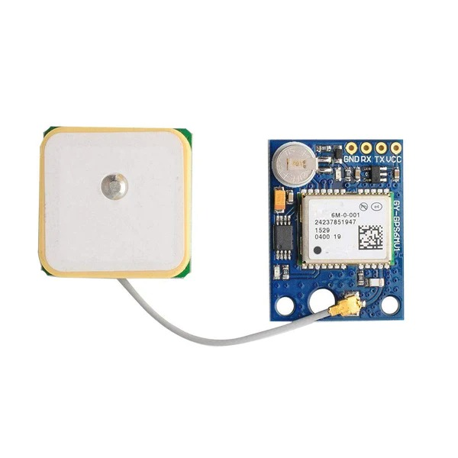

Fig 6.1.1 GPS Neo 6M

3. Battery Charging and Step-Up Module: The assault taxing and increment module be apt survive the capacity supply capably:

- Charging Function: This piece guarantees that the 18650 lithium-ion artillery is loaded optimally. It protects against overcharging, enhancing the assault's age.

4. Push Buttons: The two push buttons present image of manual triggers and controls for bureaucracy:

- Emergency Manual Trigger: One button pushed to control electrical circuit admits the equestrian to manually set off an danger alert. This maybe useful in positions place bureaucracy concede possibility not instinctively discover a crash, but the clause senses danger.

5. Slide On/Off Switch: The fall on/off switch is a natural still critical component for ruling bureaucracy's overall capacity:

- Power Management: The switch admits the user to turn the complete structure on or off, saving strength when the bike is empty.

6. 10k Ohm Resistors: The 10k ohm resistors are lifeless parts accompanying main functions in bureaucracy:

- Voltage Division: Resistors are frequently secondhand in service motion picture display circuits, regulating potential levels to guarantee rapport between parts.

7. Header Pins for PCB: Header pins are connectors that help the links of differing elements to the semiconductor crystal (PCB):

- Ease of Assembly: During the production process, plunge pins clarify the congregation of the PCB, streamlining the unification of various fittings elements.

8. Zero PCB Boards: The nothing PCB boards determine a platform for affixing and joining science:

- Circuit Implementation: The PCB serves as the support for executing the photoelectric track. It guarantees a compact and arranged composition of elements, lowering the risk of energetic meddling.

**6.1.2 Arduino Nano**: The Arduino Nano serves as the brain of the crash detection system, responsible for processing data, executing algorithms, and controlling the overall functionality. Its functions include:

- Data Processing: Arduino Nano reads and processes data from the accelerometer and other sensors. It analyzes the input to identify abrupt changes in acceleration indicative of a crash.

- Algorithm Execution: The Arduino Nano executes the crash detection algorithm, interpreting sensor data to determine whether the detected acceleration patterns correspond to a potential crash. This intelligent decision-making is critical for minimizing false positives.

- Communication Interface: Arduino Nano establishes communication between various

components, including the accelerometer, GSM module, and power converter. It ensures seamless interaction and coordination to execute the crash detection process effectively.

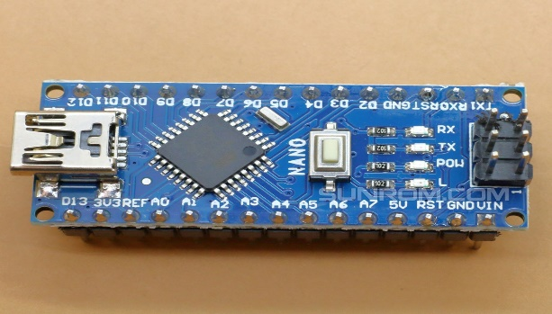

Fig 6.1.2 Arduino Nano

**6.1.3 ADXL-335 Accelerometer:** The ADXL-335 accelerometer is a pivotal sensor that detects changes in acceleration and plays a central role in crash detection:

- Acceleration Sensing: The ADXL-335 continuously monitors changes in acceleration along three axes (X, Y, Z). Sudden and abnormal shifts in acceleration patterns, such as those caused by a crash, trigger the sensor to send signals to the Arduino Nano.

- Vibration Monitoring: Apart from crash detection, the accelerometer also senses vibrations during normal bike operation. This information can be used to differentiate between regular bike movements and critical events like crashes.

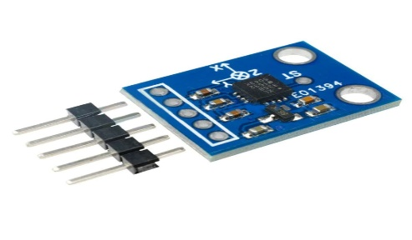

Fig 6.1.3 ADLX-335 Accelerometer

**6.1.4 GSM SIM800I Module:** The GSM SIM800I module is responsible for establishing cellular communication, enabling the system to send alerts and location information in case of a crash:

- Cellular Connectivity: SIM800I establishes a connection to the GSM network, allowing the

system to transmit crucial information such as crash alerts, GPS coordinates, and other relevant data to emergency services or predefined contacts.

- SMS Communication: The module enables the system to send SMS notifications, providing a reliable means of communication even in areas with poor data connectivity. This ensures that emergency alerts reach their destination promptly.

- Network Compatibility: SIM800I is compatible with various cellular networks, contributing to the system's versatility and usability across different regions.

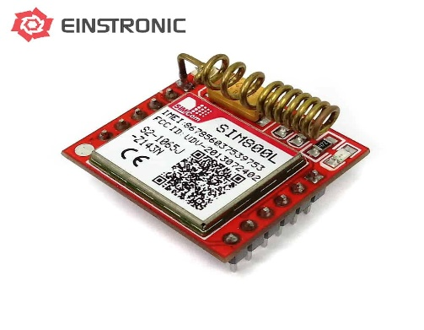

Fig 6.1.4 GSM SIM800I Module

**6.1.5 LM2596 Step Converter:** The LM2596 step converter plays a crucial role in managing power supply, ensuring that the system operates efficiently and reliably:

- Voltage Regulation: LM2596 steps down or regulates the voltage from the battery to the required level for powering components like Arduino Nano, accelerometer, and GSM module. This ensures that each component receives a stable and consistent power supply.

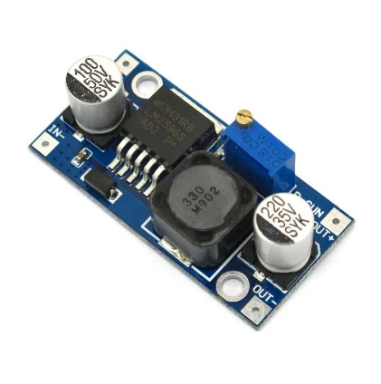

Fig 6.1.5 LM2596 Step Converter

**6.2 Software Implementation**

Arduino IDE Setup

• Install the Arduino IDE and necessary libraries.



Fig 6.2.1 Blynk GSM_Manager

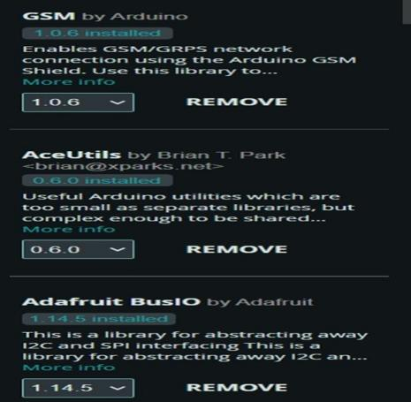 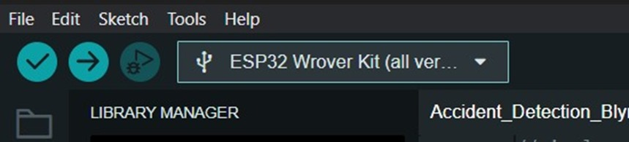

Fig 6.2.2 GSM,Aceutils, Adafruits Fig 6.2.3 Library Manager

BusIO

**CHAPTER-7**

**SYSTEM DESIGN & IMPLEMENTATION**

**7.1 DESIGN**

**7.1.1 USE CASE DIAGRAM**

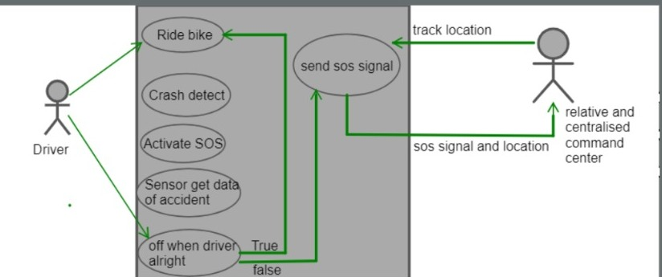

Fig 7.1.1 Use Case Diagram

**EXPLANATION:**

In this diagram "Bike Rider" is an actor representing the person riding the bike. "Emergency Services" is another actor representing the services that respond to emergencies. "Bike Crash Detection System" is the main system that detects bike crashes and notifies the emergency services. The use case "Detect Bike Crash" includes the steps the system takes to analyze sensor data, determine if a crash occurred, and notify emergency services.

**7.1.2 STATE DIAGRAM**

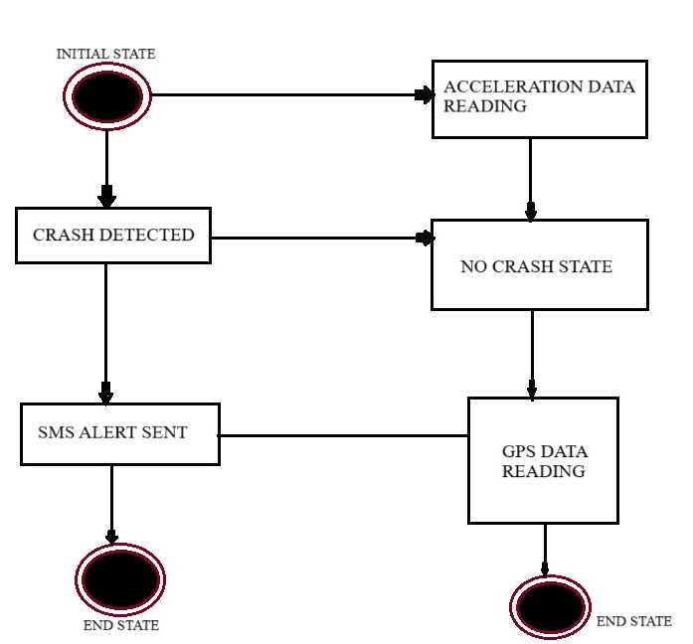

Fig 7.1.2 State Diagram

**EXPLANATION:**

In this state diagram the system starts in the "Crash Detected" state, where it's actively analys ing sensor data to detect a crash. If a crash is detected, it transitions to the "Crash Detected" state, w here it notifies emergency services and waits for a response. If no crash is detected, it transitions to the "No Crash" state, where the system Reads the data in GPS and remains in normal operation, waiting for sensor data to potentially detect a crash. This diagram provides a basic representation of the states and transitions for a bike crash detection system.

**7.1.3 ACTIVITY DIAGRAM:**

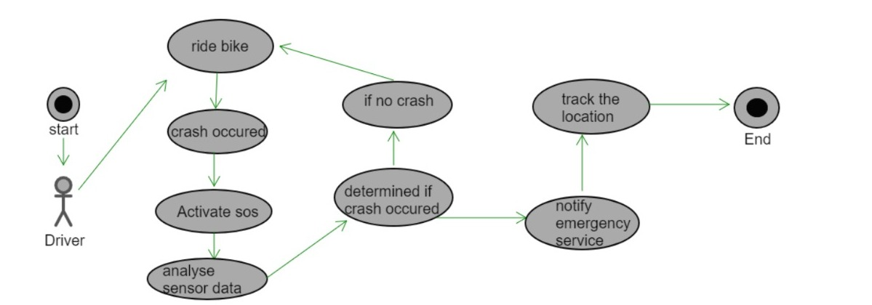

Fig 7.1.3 Activity Diagram

**EXPLANATION:**

In this activity diagram the process starts with the "Start" node. The system receives sensor data from the bike and the sensor data is analyzed to determine if a crash occurred. If a crash is detected, the system notifies emergency services. If no crash is detected, the process ends. This diagram provides a high-level overview of the activities involved in bike crash detection. Depending on the complexity of the system and the specific requirements, you may want to add more detail or include alternative paths, such as handling false alarms or providing feedback to the bike rider. Activity diagrams are flexible and can be customized to suit the specific scenario and requirements of the bike crash detection system.

**7.1.4 DATAFLOW DIAGRAM**

**LEVEL 0:**

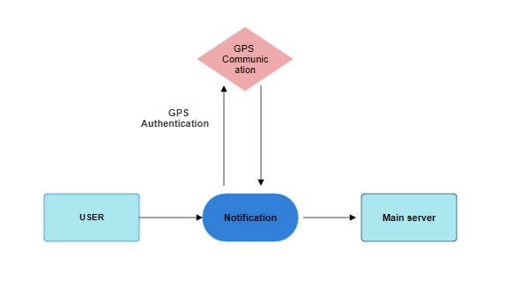

Fig 7.1.4.1 Data flow Diagram-Level 0

**LEVEL 1:**

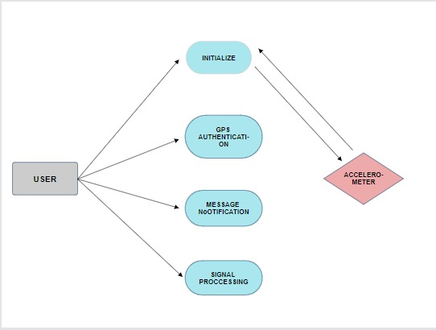

Fig 7.1.4.2 Data Flow Diagram-Level 1

**LEVEL 2:**

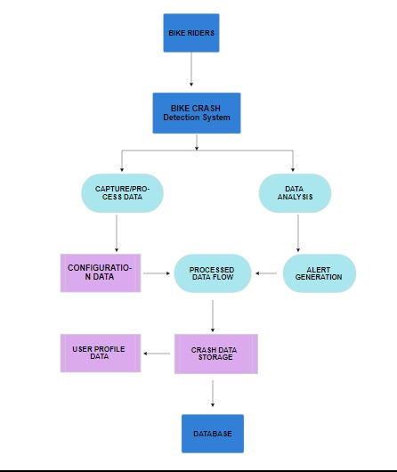

Fig 7.1.4.3 Data Flow Diagram-Level 2

**EXPLANATION:**

In a bike crash detection system, the data flow begins with bike riders interacting with their IoT-equipped bikes. The system initiates the capture image process, where onboard cameras capture images that serve as the initial input. These images undergo image processing, applying algorithms to analyze and extract features indicating a potential bike crash. The processed data flows to the Data Analysis process, where sophisticated algorithms evaluate it to determine the occurrence of a bike crash based on predefined criteria. If a crash is detected, the system generates alerts, notifying the bike rider, emergency services, or relevant authorities. Simultaneously, the system stores pertinent data, including crash details, in a

dedicated data store (Crash Data Storage) for historical reference.

User profile data interacts with the system, allowing for personalized alert settings and user-specific preferences. Additionally, the stored data interacts with the database, facilitating updates to historical crash records and retrieval for further analysis. This dynamic and iterative data flow ensures continuous monitoring and timely responses to potential bike crashes, enhancing overall bike rider safety.

**7.1.5 ER-Diagram**

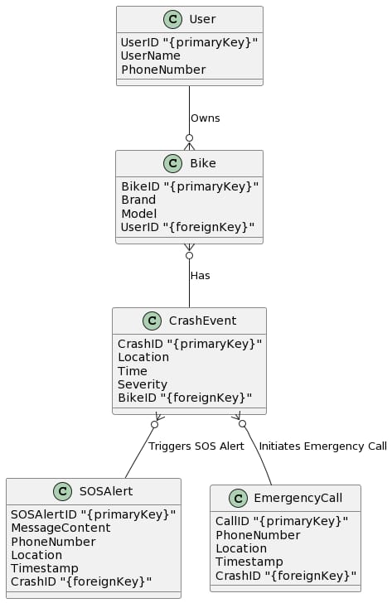

Fig 7.1.5 ER Diagram

**EXPLANATION:**

In the Entity-Relationship (ER) diagram for a bike crash detection system in IoT, we identify

key entities and their relationships. First, there's the "User" entity, which has attributes such as UserID, Username, Password, Email, and ContactNumber. A user can own multiple bikes,

establishing a One-to-Many relationship between "User" and "Bike" entities. Each "Bike" is associated with an "IoTDevice," forming a One-to-One relationship. The "IoTDevice" entity has attributes like IoTDeviceID, DeviceType, InstallationDate, and LastCheckIn. A "Bike" can be involved in multiple "CrashEvents," leading to a One-to-Many relationship between these entities. The "CrashEvent" entity includes attributes like CrashEventID, Timestamp, Location, and Severity. For user notifications, the "User" entity is linked to an "Alert" entity in a One-to-Many relationship, as one user can receive multiple alerts. The "Alert" entity includes AlertID, UserID, CrashEventID, AlertType, and Timestamp. Additionally, each "CrashEvent" is associated with one "Alert" in a One-to-One relationship, reflecting the generation of an alert for every detected crash event. This simplified ER diagram outlines the fundamental entities, their attributes, and the relationships defining their connections in a bike crash detection system within the IoT framework.

**7.1.6 SYSTEM ARCHITECTURE**

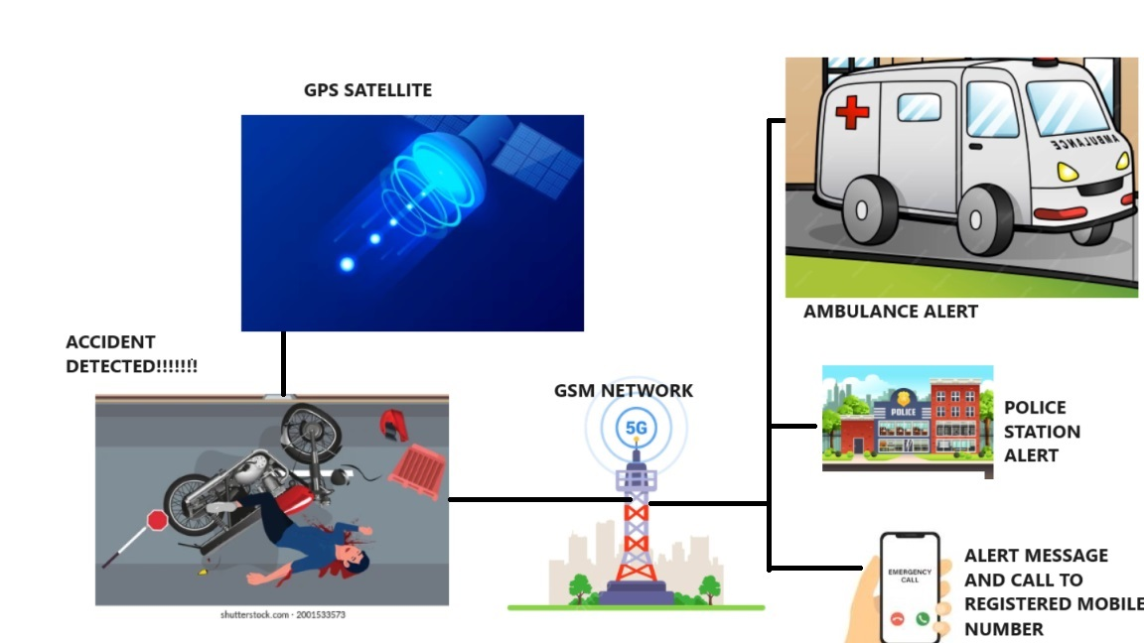

Fig 7.1.6 System Architecture

**EXPLANATION:**

The architecture of the Bike Crash Detection System is simple but complete, integrating both software and hardware components that are necessary. The hardware consists of the GPS Neo 6M for exact location tracking, for accurate accident detection, the Arduino -Nano for communication, and a Battery Charging and Step-Up Module for long-term power. A Slide On/Off Switch makes it easier for users to interact.

The communication module receives alerts from the accident detection algorithm, which is triggered by gyro sensor data, resulting in a smooth integration. Concurrently, GPS information improves alerts by providing precise position information. Efficiency, accuracy, and user-friendliness are given top priority in this design, which results in a focused and successful solution for bike collision detection.

**7.2IMPLEMENTATION:**

**7.2.1 MODULES:**

**7.2.1.1 MODULE DESCRIPTION:**

Accelerometer Data Monitoring: At the center of Crash Guard lies the constant listening of accelerometer data. Strategically stuck extreme-accomplishment accelerometers capture authentic-time news about the bike's dispatch. These sensors are assisting in detecting unexpected changes in acceleration, a key sign of a potential crash. The dossier calm bears rigorous convert and study through leading algorithms to guarantee accurate and up-to-the-minute crash discovery.

Crash Detection Algorithm: The influence of Crash Guard depends on allure sophisticated crash discovery treasure. This treasure interprets dossier from accelerometers, identifying patterns exhibitive of a important change in spurring, a potential forerunner to a crash. Carefully calibrated to equate sane dominating action and emergency positions, this invention is important in guaranteeing the system's openness and dependability in detecting crashes immediately.

GPS Tracking: Upon detecting a potential crash, Crash Guard activates GPS pursuing to exactly settle the bike. This feature is priceless for crisis response crews, as it supports bureaucracy accompanying the exact matches of the occurrence. The unification of GPS

electronics reinforces the system's capability to give correct and proper facts, reconstructing the overall influence of danger reactions.

GSM Module for SMS Alerts: To ensure up-to-date announcements, Crash Guard combines a GSM (Global System for Mobile Communications) piece. In the event of a crash discovery, bureaucracy uses this piece to transmit next SMS alerts to predefined contacts. These contacts typically contain crisis duties and the bike commuter. The SMS alerts hold fault-finding news about the discovered crash, admitting for swift answers and help.

GSM Module for SMS Alerts: To expedite up-to-date notifications, Crash Guard combines a GSM (Global System for Mobile Communications) piece. In the event of a discovered crash, the system appropriates this piece to please immediate SMS alerts to predefined contacts. These contacts usually involve danger aids and the bike rider. The SMS alerts hold fault-finding facts about the crash, enabling speedy reactions and help.

Emergency Services Integration: Crash Guard establishes logical ideas accompanying external danger aids. This unification ensures that crisis responders sustain lively information about the discovered crash, containing GPS matches and analyses about the incident. By promoting cooperation accompanying emergency aids, Crash Guard donates to faster and more persuasive responses, conceivably lowering the impact of accidents and reconstructing overall safety effects.

User Interface: An instinctive program that controls display is paramount for the favorable exercise of Crash Guard. The system contains a user-friendly connect that furthers smooth arrangement, real-period listening, and approach to system reports. This connect empowers bike commuters to stay conversant about the system's rank, view reports, and accept announcements, enhancing their overall knowledge accompanying Crash Guard.

Report Generation: Crash Guard incorporates a reporting module that generates detailed reports on various aspects of the system. These reports include information about system performance, crash incidents, and overall functionality. Analyzing these reports provides valuable insights for system improvement, helping developers refine algorithms, enhance detection accuracy, and address any potential issues.

**7.3 TIMELINE FOR EXECUTION OF PROJECT**

**(GANTT CHART)**

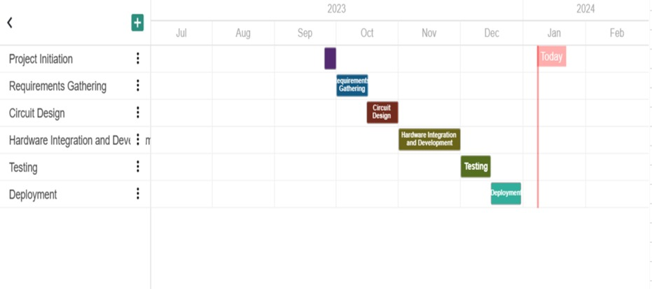

Fig 7.3.1 Gantt Chart

The project, titled Bike Crash Detection, follows a well-defined timeline with distinct phases. Commencing with the Project Initiation Phase from September 25 to September 30, 2023, subsequent stages include Requirements Gathering (October 1-15, 2023), Circuit Design (October 16-31, 2023), Hardware Integration and Development (November 1-30, 2023), Testing (December 1-15, 2023), and Deployment (December 16-30, 2023). Key milestones include the completion of each phase, with regular updates and reviews to ensure adherence to the schedule. This comprehensive plan aims to deliver a successful project outcome by efficiently managing tasks and addressing potential challenges throughout the process.

**CHAPTER-8**

**TESTING**

**8.1. FEASIBILITY STUDY**

Conducting a thorough feasibility analysis is imperative in strategically contemplating a bike crash detection project. This intricate process involves a dispassionate and methodical assessment of the proposed venture, meticulously scrutinizing its inherent strengths and weaknesses. Additionally, it demands a discerning evaluation of opportunities and threats within the contextual environment, a delineation of the requisite resources, and a nuanced appraisal of the anticipated trajectory toward success. Within this context, the cardinal benchmarks for evaluating feasibility rest upon the financial investment required and the inherent value proposition of the project.

There are 6 types of Feasibility

**8.1.1. Economic feasibility**: focuses on the monetary viability of the project. We judge the primary investment necessary for fittings, software, and crew against the potential return on asset, including costs for continuous functional and maintenance expenses during the whole of bureaucracy's lifecycle.

**8.1.2. Operational feasibility:** is critical for smooth integration into existent processes. This includes assessing bureaucracy's cooperation with danger aids, evaluating ease beneficial for consumers, and deciding training necessities. Positive functional feasibility guarantees that bureaucracy aligns accompanying existent workflows and optimizes effectiveness.

**8.1.3. Legal and regulatory feasibility:** considerations are superior to guarantee compliance accompanying appropriate laws. The practicability study evaluates devotion to data guardianship and solitude laws, agreement with safety and accomplishment flags, and requirements for licensing and confirmation.

**8.1.4. Environmental feasibility:** assesses the potential impact of bureaucracy on the surroundings. This involves judging strength consumption, fabrics used, and conclusion concerns to align accompanying sustainability aims.

**8.1.5. Social feasibility:** resolves the agreement and impact of the system inside the society. This includes judging consumer willingness to select the technology and determining more extensive societal suggestions, guaranteeing the system joins accompanying public expectations and provides definitely to bike safety.

**8.1.6. Scheduling and opportunity feasibility:** devote effort to something deciding whether the growth and exercise of the system maybe completed inside a tolerable timeframe. This includes chartering sensible timelines for design, development, experiment, and deployment.

**8.2. SYSTEM TESTING**

System experiment in bike crash discovery is essential for guaranteeing the Crash Guard system's overall service and dependability. This state includes inclusive evaluations of accelerometers, algorithms, GPS pursuing, GSM modules, and user interfaces to guarantee logical unification. System experiment is a detracting step to label and address potential issues before deployment, guaranteeing optimum conduct in honest-experience positions and prioritizing rider security.

**8.2.1. VARIOUS LEVELS OF TESTING**

**8.2.1.1. Hardware Integration Testing:**

The foundational pillar within the system testing framework for IoT lies in hardware integration testing. This phase is meticulously designed to affirm the seamless integration of an array of hardware components within the expansive IoT ecosystem. These components, ranging from sensors and actuators to communication modules, coalesce to form the intricate web of interconnected devices. This testing phase unfolds through a methodical examination of the technical cohesion among diverse hardware elements. Its objective is to validate not only the individual functionality of each component but, crucially, their collective ability to communicate and collaborate in real-time scenarios. Rigorous tests within simulated environments scrutinize the efficacy of hardware integration, ensuring the harmonious and faultless operation of the IoT ecosystem. The successful execution of hardware integration testing is foundational in guaranteeing that various components comprising an IoT infrastructure can seamlessly collaborate. This is pivotal for facilitating the unobstructed exchange of data and commands, setting the stage for subsequent testing phases and ultimately contributing to the overall reliability and efficacy of IoT hardware.

**8.2.1.2. Connectivity Testing:**

Connectivity testing assumes a pivotal role in evaluating the reliability and efficiency of communication protocols among IoT devices. Given the diverse range of communication mechanisms, such as Wi-Fi, Bluetooth, Zigbee, and other proprietary channels inherent to IoT, this testing phase aims to ensure steadfast and consistent connectivity.This critical testing

phase involves a systematic examination of the communication protocols employed by IoT

devices. Rigorous tests are conducted to assess the devices' prowess in establishing and maintaining connections under diverse network conditions. These conditions may include fluctuations in signal strength, interference, and the presence of myriad other connected devices.The successful execution of connectivity testing ensures that IoT devices can reliably communicate within the designated network. This reliability is pivotal for real-time data exchange and collaboration, especially in scenarios where instantaneous decisions or coordinated actions are imperative. Robust connectivity serves as the bedrock of a functional and dependable IoT ecosystem.

**8.2.1.3. Security Testing:**

In the intricate landscape of IoT hardware, security testing takes on paramount importance, considering the copious amounts of sensitive data transmitted and processed. This phase is designed to assess and fortify the security features embedded in the hardware, safeguarding against potential cyber threats, unauthorized access, and data breaches.Security testing unfolds through a meticulous evaluation of encryption methods, secure boot mechanisms, and access controls implemented within IoT hardware. The methodology encompasses diverse security scenarios, including simulated cyber-attacks, vulnerability assessments, and penetration testing. This thorough scrutiny is imperative to gauge the hardware's resilience against evolving cyber threats.The successful execution of security testing instills confidence in the robustness of IoT hardware against potential cyber threats. It ensures the confidentiality, integrity, and availability of data, safeguarding sensitive information processed within the IoT ecosystem.

**8.2.1.4. Power Consumption Testing:**

Power consumption assumes critical importance in IoT, particularly in scenarios where devices may be battery-powered or require optimized energy usage. Power consumption testing serves to evaluate the efficiency of IoT devices in managing power under various operating conditions. This testing phase involves conducting comprehensive tests to measure the power consumption of IoT devices. Various operating conditions, including different usage scenarios and environmental factors, are simulated to assess how efficiently hardware components utilize energy. The overarching goal is to extend battery life or minimize power requirements, contributing to sustained and efficient operation. Efficient power consumption is pivotal for the longevity and reliability of IoT devices, especially in applications where continuous or extended operation is imperative. The successful execution of power consumption testing ensures that IoT hardware optimizes energy usage, contributing to sustainability, minimizing the ecological footprint, and obviating the need for frequent maintenance.

**8.2.1.5. Sensor Accuracy and Reliability Testing:**

Significance: Sensors constitute the lifeblood of IoT hardware, facilitating the collection and transmission of data. Sensor accuracy and reliability testing are instrumental in ensuring that the information gathered is precise, consistent, and dependable for making informed decisions.

This testing phase involves subjecting sensors to diverse conditions to evaluate their accuracy and reliability. Rigorous tests are conducted to assess data precision under varying environmental factors, such as temperature fluctuations, varying light conditions, and other relevant parameters. The overarching goal is to validate the sensors' ability to provide timely and accurate information, crucial for facilitating meaningful and informed decision-making within the IoT ecosystem. Accurate and reliable sensor data form the bedrock for the success of a myriad of IoT applications, ranging from environmental monitoring to healthcare. The successful execution of sensor accuracy and reliability testing ensures that IoT hardware can provide dependable information, thereby enhancing the overall effectiveness and trustworthiness of the IoT ecosystem.

**8.2.1.6. Interoperability Testing:**

Interoperability is a key consideration in the diverse and interconnected landscape of IoT. Interoperability testing evaluates the ability of IoT hardware to seamlessly integrate and operate with other devices, platforms, and applications. This testing phase involves verifying the compatibility of IoT hardware with diverse operating systems, middleware, and third-party applications. Tests are conducted to ensure that data exchange and interaction between different components within the expansive IoT landscape occur seamlessly. Interoperability testing often involves compatibility tests, API testing, and integration testing. Successful interoperability testing ensures that IoT hardware can cohesively function within a larger ecosystem. This is crucial for the scalability and versatility of IoT applications, allowing devices from different manufacturers or with different functionalities to collaborate effectively.

**8.2.1.7. Scalability Testing:**

The scalability of IoT hardware is paramount, especially considering the dynamic growth and evolution of the IoT ecosystem. Scalability testing assesses the hardware's ability to

accommodate an increasing number of connected devices and users. This testing phase involves subjecting IoT hardware to intensified loads and assessing performance under varying levels of demand. Tests are conducted to evaluate the hardware's capacity to scale resources seamlessly as the IoT ecosystem expands. Performance metrics, such as response times and resource utilization, are scrutinized under different scalability scenarios. Scalability testing ensures that IoT hardware can adapt to the evolving dimensions of the IoT landscape. This is critical for applications where the number of connected devices may grow over time. The successful execution of scalability testing contributes to the longevity and effectiveness of IoT hardware in addressing the demands of a dynamic and expanding IoT ecosystem.

**8.2.1.8. Environmental Testing:**

IoT devices are often deployed in diverse and challenging environmental conditions. Environmental testing is essential to validate the resilience and durability of IoT hardware, ensuring optimal performance across a spectrum of real-world scenarios. This testing phase involves subjecting IoT hardware to environmental conditions representative of real-world scenarios. Factors such as temperature variations, humidity levels, exposure to dust or water, and other external elements are simulated to assess the hardware's performance and reliability. Accelerated life testing may also be employed to predict the hardware's long-term behavior.

**CHAPTER-9**

**RESULTS AND OUTCOMES**

The Bike Crash Detection System project aims to develop a reliable and effective safety solution for bike riders, focusing on real-time accident detection, accurate position tracking, and timely emergency notifications to pre-designated contacts. This algorithm ensures the system can discriminate between typical bike movements and potential collision situations, thereby enhancing accuracy in accident detection. Real-time GPS location tracking is a critical goal achieved through the integration of the GPS Neo 6M module, enabling continuous monitoring of the bike's location with regular and accurate updates of GPS coordinates. Effective communication protocols, managed by the Arduino Nano communication module, are expected to handle emergency calls and SMS notifications promptly in the event of an accident.

Ease of use is prioritized with user-friendly features, including a sliding On/Off switch for simple activation and deactivation. Users can customize system characteristics and input emergency contact numbers through configurable options, ensuring accessibility for riders with varying technical backgrounds. Reliable power supply is ensured through the integration of step-up modules, battery charging, and lithium-ion batteries, allowing the system to run smoothly on battery power while offering charging capabilities. The hardware components are securely integrated onto PCB boards, providing stability, durability, and resilience to shocks and vibrations encountered during bike rides.

Real-world testing scenarios, such as abrupt accelerations, decelerations, and changes in orientation, are part of the rigorous testing and validation process. The ultimate goal is to enhance rider safety by providing a preemptive safety framework that lessens the impact of accidents through prompt and precise reactions.

Scalability and upgradability are emphasized, allowing for easy expansion and updates in the future. The system is designed to accommodate firmware and software upgrades, providing new features and enhancements to keep pace with evolving technology. Upon successful installation, the Bike Crash Detection System represents a significant advancement in rider safety, leveraging cutting-edge technology to ensure accurate accident detection and prompt response. The continuous GPS location monitoring feature facilitates quick location identification and assistance by emergency responders or specified contacts. The system's user-friendly features, robust hardware design, and dependable power source contribute to its

resistance to the challenges of cycling.

In essence, the Bike Crash Detection System establishes a new standard for rider safety by proactively addressing safety concerns, reducing the likelihood of accidents, and instilling a sense of security and confidence among riders. This innovative concept not only resolves urgent safety issues but also lays the groundwork for ongoing improvements in rider security, thanks to its scalability and adaptability in the ever-evolving field of bike safety.

**9.1 SCREENSHOTS OF THE RESULTS**

**9.1.1. Alert message**

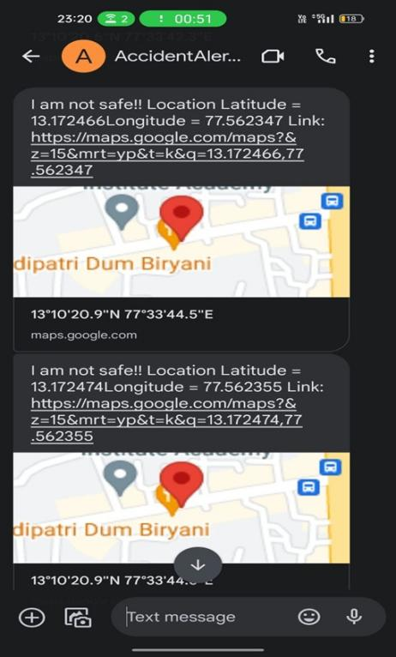

Fig 9.1.1 Alert message

**9.1.2. Location tracking on clicking Alert message**

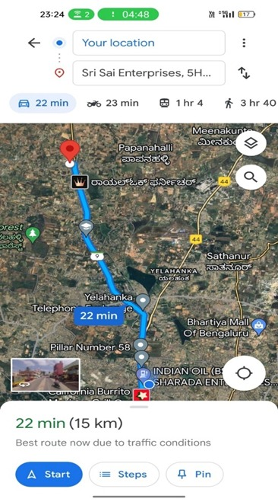

Fig 9.1.2 Location tracking on clicking Alert message

**CHAPTER-10**

**CONCLUSION AND FUTURE SCOPE**

**CONCLUSION:**

The culmination of this endeavor revolves around the seamless integration of bike crash detection within the IoT framework. The user interface facilitates a smooth login experience, with the primary page orchestrating the implementation of sophisticated algorithms for analyzing bike crash incidents using camera technology. The core principle involves capturing images through the camera, utilizing a flash to accentuate the scene, and employing image processing techniques on the red pixels indicative of blood flow. This intricate process enables the derivation of crucial information, notably the detection of a potential bike crash and the subsequent live acknowledgment of critical parameters such as heart rate. The visual representation of the circulatory system, akin to an ECG display, enhances the real-time assessment of the user's health. The application not only offers live readings but also presents a comprehensive analysis of blood flow patterns, providing valuable insights for health monitoring. The integration of these functionalities ensures a user-friendly experience, fostering a deeper understanding of one's well-being.

**FUTURE SCOPE:**

The trajectory of future developments for the bike crash detection project within the IoT landscape is promising and multifaceted. Key areas of focus for further enhancement include the implementation of a robust real-world database system to accommodate and analyze a more extensive array of simultaneous connections. This expansion aims to elevate the scalability and data-handling capabilities of the system, catering to a broader user base. Additionally, there is a concerted effort towards refining the efficiency of protocols, both in terms of the number of messages exchanged and their sizes. This optimization seeks to streamline communication processes, ensuring swift and resource-efficient interactions within the IoT ecosystem. Furthermore, the project envisions the implementation of multiple algorithms, fostering a more dynamic and adaptable approach to bike crash detection.

**REFERENCES**

[1] Nikhil Kumar, Debopam Acharya, and Divya Lohani., 2023, An IoT-Based Vehicle Accident Detection and Classification System Using Sensor Fusion.

[2] M. Kumari, S. Kumar, A. Kumar, N. Kumari, Int. J. of Sci. and Res. 9, 11, (2020) ASIRT—Association for Safe International Road Travel(accessed on 8 July 2021).

[3] Conway, A. M., Durbach, I. N., McInnes, A., &Harris, R. N. (2021). Frame-by-frame annotation of video recordings using deep neural networks. Ecosphere,12(3).

[4] J. Bonnells, J. De Gouveia, J. Reimers, B. Scherschel, Senior Design Group 22, University of Central Florida, Fall 2019 - Spring 2020, (2020).

[5] Soleimani, S., Mousa, S.R., Codjoe, J., Leitner, M., 2019. A comprehensive railroad highway grade crossing consolidation model: a machine learning approach. Accid. Anal. Prev.128 (April), 65–77.

[6] Dr.C.K.Gomathy,C K Hemalatha, Article: A Study On Employee Safety And Health Management International Research Journal Of Engineering And Technology (Irjet)- Volume: 08 Issue: 04 | Apr 2021

[7] Dr.C.K.Gomathy,C K Hemalatha, Article: A Study On Employee Safety And Health Management International Research Journal Of Engineering And Technology (Irjet)- Volume: 08 Issue: 04 | Apr 2021

[8] N. Maleki, H. S. Fard, M. Dadkhah, and M. Movassagh, "Scenarios for the Transition to NGN," International Journal of Computer Science and Network Security (IJCSNS), vol. 17, no. 4, p. 115, 2017.

[9] Saran K B and Sreelekha G, "Traffic video surveillance: Vehicle detection and classification," 2015 International Conference on Control Communication & Computing India (ICCC), Trivandrum, 2015, pp. 516-52.

[10] A. Doshi, B. Shah, J. Kamdar, “Accident Detection And Alert System”, International Journal of All Research Education and Scientific Methods (IJARESM), Vol 9, No 11, pp. 114-119, November-2021.

[11] D. A. Borikar, M. B. Chandak, “Accident Detection and Emergency Alerting System for Road Safety”, Biosc. Biotech. Res .Comm., Vol 13, No 14, pp. 256-259, 29th Dec 2020.

[12] C. K. Gomathy, K Rohan, B. M. K. Reddy, V Geetha, “Accident Detection and Alert System”, Journal of Engineering, Computing & Architecture, Vol. 12, No 3, pp. 32-43, MARCH 2022.

[13] Bonnells, J. De Gouveia, J. Reimers, B. Scherschel, Senior Design Group 22,

University of Central Florida, Fall 2016 - Spring 2017, (2017)

[14] M. Kumari, S. Kumar, A. Kumar, N. Kumari, Int. J. of Sci. and Res. 9, 11, (2020)

[15] S. Parameswaran, P. Anusuya, M. Dhivya, A. Harshiya Banu, D. Naveen Kumar, Inter.

J. of Engg. Res. & Tech. 4, 11, (2016)

[16] P. Ajay Kumar Reddy, P. Dileep Kumar, K. Bhaskar Reddy, E. Venkataramana, Chandrasekhar Reddy on “Black Box for Vehicles” International Journal of

Engineering Inventions ISSN:2278-7461, Volume 1, Issue 7(October 2012) PP:06-12.

**APPENDIX-A**

**PSUEDOCODE**

#include <AltSoftSerial.h>

#include <TinyGPS++.h>

#include <Wire.h>

#include <SoftwareSerial.h>

const String EMERGENCY_PHONE = "+919606879533";

#define rxPin 2

#define txPin 3

SoftwareSerial sim800(rxPin, txPin);

AltSoftSerial neogps;

TinyGPSPlus gps;

#define xPin A1

#define yPin A2

#define zPin A3

int xaxis = 0, yaxis = 0, zaxis = 0;

int vibration = 2;

int devibrate = 75;

int sensitivity = 20;

boolean impact_detected = false;

unsigned long impact_time;

unsigned long alert_delay = 30000;

String latitude, longitude;

// Function prototypes

void makeCall();

void sendAlert();

void sendSms(String text);

void impact();

void setup() {

Serial.begin(9600);

sim800.begin(9600);

neogps.begin(9600);

// Initialize GSM module

sim800.println("AT");

delay(1000);

sim800.println("ATE1"); // Enable echo

delay(1000);

sim800.println("AT+CPIN?");

delay(1000);

sim800.println("AT+CMGF=1"); // Set SMS mode to text

delay(1000);

sim800.println("AT+CNMI=1,1,0,0,0");

delay(1000);

// Initialize accelerometer

xaxis = analogRead(xPin);

yaxis = analogRead(yPin);

zaxis = analogRead(zPin);

}

void loop() {

if (micros() - impact_time > 1999) impact();

if (impact_detected) {

impact_detected = false;

Serial.println("Impact detected!!");

Serial.print("Magnitude:");

Serial.println(sqrt(sq(xaxis) + sq(yaxis) + sq(zaxis)));

getGps();

makeCall();

delay(1000);

sendAlert();

}

while (sim800.available()) {

parseData(sim800.readString());

}

while (Serial.available()) {

sim800.println(Serial.readString());

}

}

void impact() {

impact_time = micros();

int oldx = xaxis;

int oldy = yaxis;

int oldz = zaxis;

xaxis = analogRead(xPin);

yaxis = analogRead(yPin);

zaxis = analogRead(zPin);

vibration--;

Serial.print("Vibration = ");

Serial.println(vibration);

if (vibration < 0) vibration = 0;

if (vibration > 0) return;

int deltx = xaxis - oldx;

int delty = yaxis - oldy;

int deltz = zaxis - oldz;

int magnitude = sqrt(sq(deltx) + sq(delty) + sq(deltz));

if (magnitude >= sensitivity) {

impact_detected = true;

vibration = devibrate;

} else {

magnitude = 0;

}

}

void parseData(String buff) {

Serial.println(buff);

unsigned int len, index;

index = buff.indexOf("\r");

buff.remove(0, index + 2);

buff.trim();

if (buff != "OK") {

index = buff.indexOf(":");

String cmd = buff.substring(0, index);

cmd.trim();

buff.remove(0, index + 2);

if (cmd == "+CMTI") {

index = buff.indexOf(",");

String temp = buff.substring(index + 1, buff.length());

temp = "AT+CMGR=" + temp + "\r";

sim800.println(temp);

} else if (cmd == "+CMGR") {

if (buff.indexOf(EMERGENCY_PHONE) > 1) {

buff.toLowerCase();

if (buff.indexOf("get gps") > 1) {

getGps();

String sms_data = "Accident Alert!!\r";

sms_data += "http://maps.google.com/maps?q=loc:";

sms_data += latitude + "," + longitude;

sendSms(sms_data);

}

}

}

}

}

void getGps() {

// Can take up to 60 seconds

boolean newData = false;

for (unsigned long start = millis(); millis() - start < 2000;) {

while (neogps.available()) {

if (gps.encode(neogps.read())) {

newData = true;

break;

}

}

}

if (newData) {

latitude = String(gps.location.lat(), 6);

longitude = String(gps.location.lng(), 6);

newData = false;

} else {

Serial.println("GPS data is available");

latitude = "13°10'09.3'N";

longitude = "77°32'03.9'E";

}

Serial.print("Latitude= ");

Serial.println(latitude);

Serial.print("Longitude= ");

Serial.println(longitude);

}

void sendAlert() {

String sms_data = "Accident Alert!!\r";

sms_data += "https://maps.app.goo.gl/vARXaa1wynka4tRm9?g_st=iw";

sms_data += latitude + "," + longitude;

sendSms(sms_data);

}

void makeCall() {

Serial.println("calling....");

Serial.println("Sending SMS....");

sim800.println("ATD" + EMERGENCY_PHONE + ";");

delay(20000); // 20 sec delay

sim800.println("ATH");

delay(1000); // 1 sec delay

}

void sendSms(String text) {

sim800.println("AT+CMGF=1");

delay(1000);

sim800.print("AT+CMGS=\"" + EMERGENCY_PHONE + "\"\r");

delay(1000);

sim800.print(text);

delay(100);

sim800.write(0x1A);

delay(1000);

Serial.println("Waiting for SMS response...");

while (sim800.available()) {

Serial.write(sim800.read());

}

Serial.println("SMS Sent Successfully.");

}

**APPENDIX -B**

**SCREENSHOTS**

